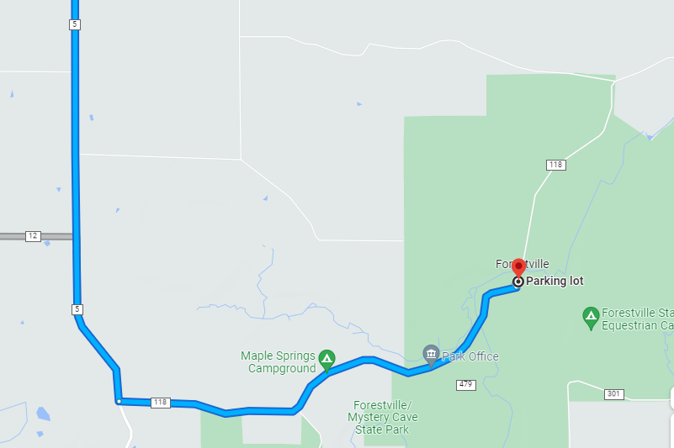
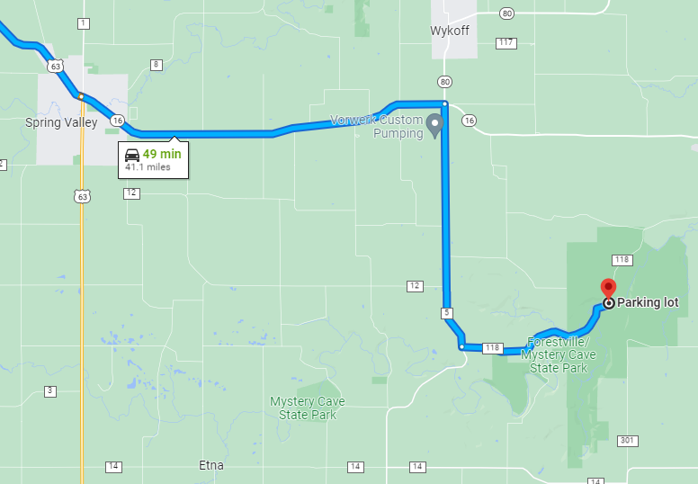
After you see the Maple Springs Campground on the left, the Park Office is down the road on the right, well set into the trees. Stop there to let them know you are going to the public dark sky viewing.
The easiest route to the viewing area is east out of Spring Valley, and then turn south on Hwy 5. Signs will direct you into the park on County Road 118. All paved.
MAP 2

MAP 1

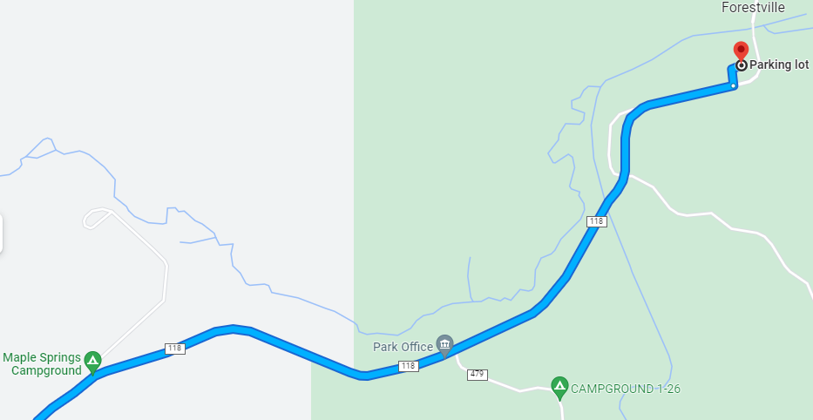
Go to the end of the paved road. We will be setting up in parking lot and/or the remaining dead-end road just short of the closed bridge to Forestville.
MAP 3
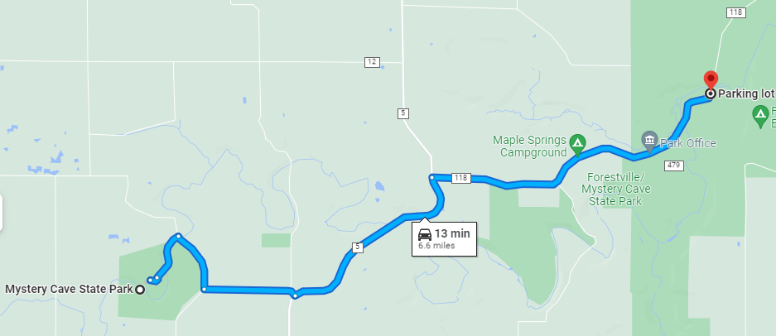
To get to the afternoon solar viewing, use the same route, but follow the signage past the turn-off to Forestville and follow the signs to Mystery Cave. The last couple miles are gravel road.
MAP 4

